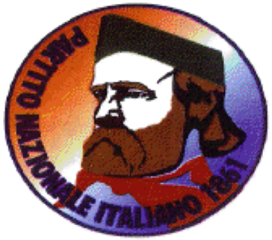
www.partitonazionaleitaliano.com

His Majesty King Mohammed VI
Royal Palace
Rabat
Morocco
17 December 2024

NOTE VERBALE No.0155/1128/SP

Your Majesty,

Partito Nazionale Italiano and myself as Segretario Politico extend compliments and greetings to Your Majesty, the government and citizens of Morocco and I have the honour to present this request on behalf of Lee Brahim Murray-Lamrani (born 12 November 1977) currently detained in Morocco for many years.
With the utmost respect and humility, I address this Note Verbale to Your Majesty, via Your esteemed Ambassador in Rome, invoking the divine virtues of compassion, mercy, and justice that have always been a cornerstone of your enlightened reign. In accordance with Article 58 of the Moroccan Constitution, which grants Your Majesty the right of pardon, I submit this plea for the commutation of sentence and removal of Mr. Lee Murray to the United Kingdom.
Mr. Murray, though convicted of grave offenses, has served a substantial part of his sentence in Morocco, demonstrating in the last few years sincere efforts toward rehabilitation. Mercy, as a divine attribute, offers not only redemption for the individual but a reflection of the magnanimity and progressive human rights principles of Your Majesty's rule.
In granting this request, I respectfully highlight seven significant benefits for Morocco:
- International Diplomacy:
This act would enhance Morocco’s reputation as a nation committed to the principles of humanity, dignity, and justice, strengthening its diplomatic relations with the United Kingdom and the European Union.
- Human Rights Leadership:
Your Majesty's clemency would reaffirm Morocco's global standing as a leader in advancing human rights and judicial fairness, resonating with international audiences and organizations.
- Support for Rehabilitation:
By allowing Mr. Murray’s return to his home country, Your Majesty underscores the belief in rehabilitation over retribution, fostering global discussions on humane justice systems.
- Cultural and Religious Values:
Mercy is deeply embedded in both Moroccan and Islamic traditions. This act of clemency would serve as a powerful demonstration of these shared values to the world.
- Strengthened Bilateral Ties:
The United Kingdom would view this gesture as a profound act of goodwill, paving the way for enhanced cooperation in trade, cultural exchanges, and mutual support on international platforms.
- Judicial Resource Optimization:
Reducing the burden on Morocco’s correctional system by returning Mr. Murray would demonstrate efficiency and practicality in addressing penal challenges.

- Symbol of Modern Justice:
This decision would embody Morocco's commitment to progressive judicial practices, setting a precedent for balanced justice and inspiring other nations in similar situations.
Your Majesty, Mr. Murray’s case presents an opportunity for Morocco to exemplify the virtues of mercy and rehabilitation. By granting this request, you provide not only a path for Mr. Murray to reintegrate into society but also a beacon of hope for countless others who believe in the transformative power of justice tempered with compassion.
Partito Nazionale Italiano extends its compliments and greetings and with profound respect and unwavering faith in Your Majesty’s wisdom, remains,
Yours sincerely,

Giovanni Di Stefano
Giovanni Di Stefano
Segretario Politico
Partito Nazionale Italiano
+39 329 627 4773
Gdistefano1955.2mail.com

- Cc Moroccan Embassy in Rome
Via Brenta, 12/16
00198 Roma
Italy
H.E. Ambassador Mr. Youssef Balla

